Practice 1
Write a check to the landlord to pay the rent for one month.
The landlord’s name is Mr. Bill Long. The rent is $425.00

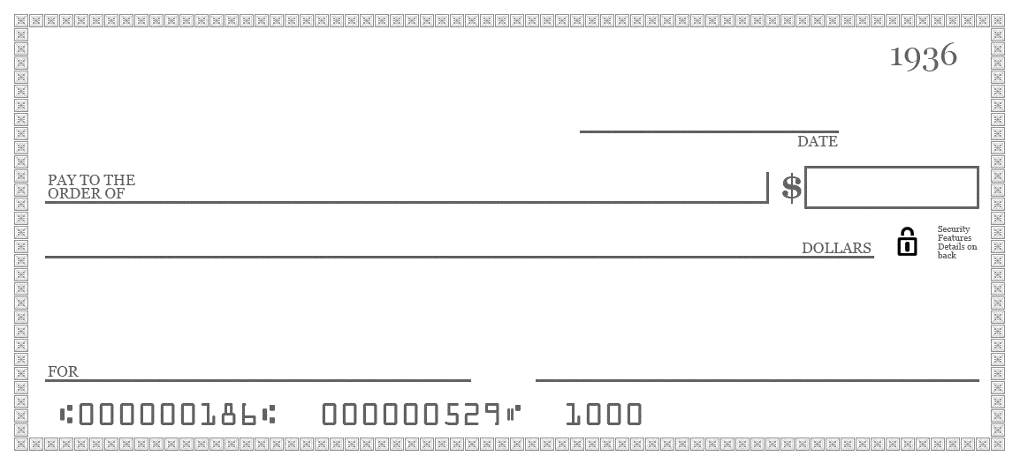

Write a check to the landlord to pay the rent for one month.
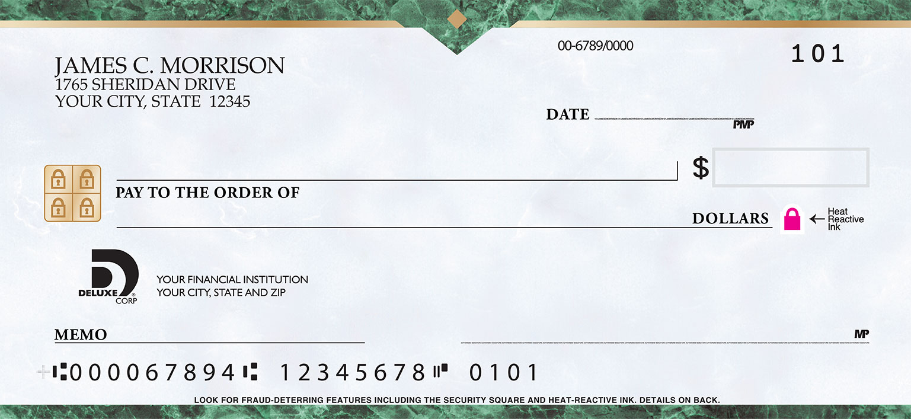
The landlord’s name is Mrs. Sandra Chase. The rent is $365.00

Practice 2
Write a check to the landlord to pay the rent for one month.
The landlord’s name is Mr. Charles DeLong. The rent is $555.00

Write a check to the landlord to pay the rent for one month.
The landlord’s name is Mrs. Tina Glass. The rent is $485.00

Practice 3
Write a check to the landlord to pay the rent for one month.
The landlord’s name is Mr. Timothy Jacobs. The rent is $535.00

Write a check to the landlord to pay the rent for one month.
The landlord’s name is Mr. Alex Garcia. The rent is $345.00

Practice 4

Write a check to the landlord to pay the rent for one month.
The landlord’s name is Mrs. Maria Sanchez. The rent is $475.00

Write a check to the landlord to pay the rent for one month.
The landlord’s name is Mr. Alan Thompson. The rent is $395.00

Practice 5

Write a check to the landlord to pay the rent for one month.
The landlord’s name is Mr. Greg Robinson. The rent is $545.00

Write a check to the landlord to pay the rent for one month.
The landlord’s name is Mr. Jim Roberts. The rent is $435.00

Practice 6

Write a check to the landlord to pay the rent for one month.
The landlord’s name is Mrs. Tracy McAnear. The rent is $525.00

Write a check to the landlord to pay the rent for one month.
The landlord’s name is Mr. Will Brown. The rent is $335.00

Practice 7

Write a check to the landlord to pay the rent for one month.
The landlord’s name is Mrs. Suzanne Gold The rent is $735.00

Write a check to the landlord to pay the rent for one month.
The landlord’s name is Mr. Kirk Stone. The rent is $265.00

Practice 8

Write a check to the landlord to pay the rent for one month.
The landlord’s name is Mr. Thomas Stage. The rent is $645.00

Write a check to the landlord to pay the rent for one month.
The landlord’s name is Mrs. Julie Trent. The rent is $375.00

Practice 9

Write a check to the water company.
The water company is City Corporation of Russellville.
The amount on your bill is $46.26. Your account number is 22735.

Write a check to the electric company.
The electric company is Entergy.
The amount on your bill is $167.49. Your account number is 36987.
Practice 10

Write a check to the electric company.
The electric company is Entergy.
The amount on your bill is $84.13. Your account number is 22896.

Write a check to the water company.
The water company is City Corporation of Russellville.
The amount on your bill is $31.24. Your account number is 4197.

